The VBG and VCG Comparison
1.In VCG the Lowest price with trade in offer is not available in VBG
VCG | VBG
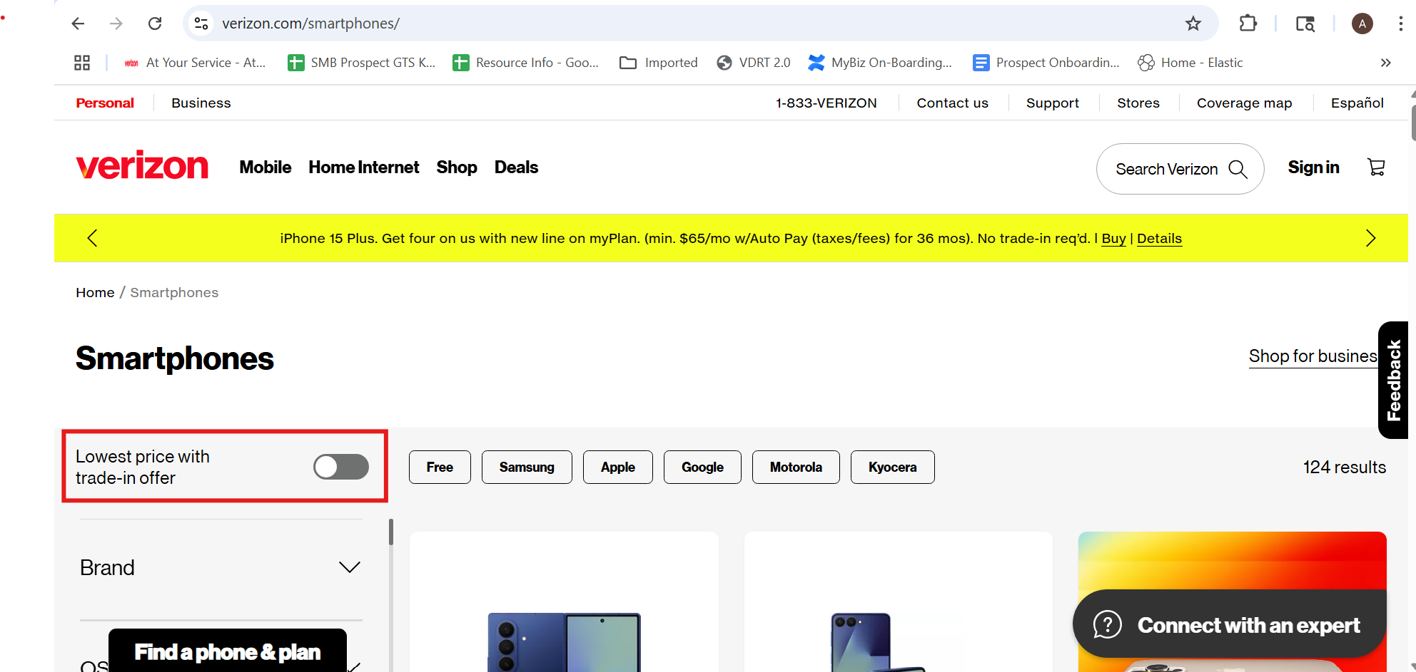 | 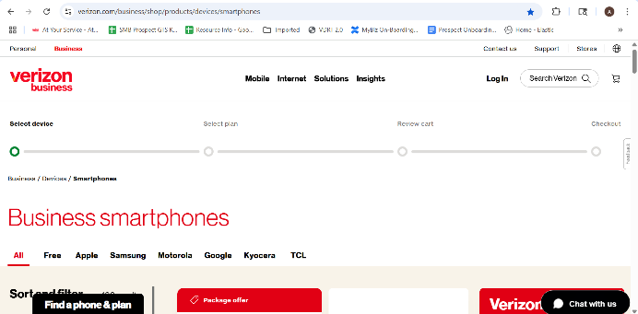

2.The sign up option in the end of the VCG page is not their and register option is not found in the top of VBG
VCG | VBG
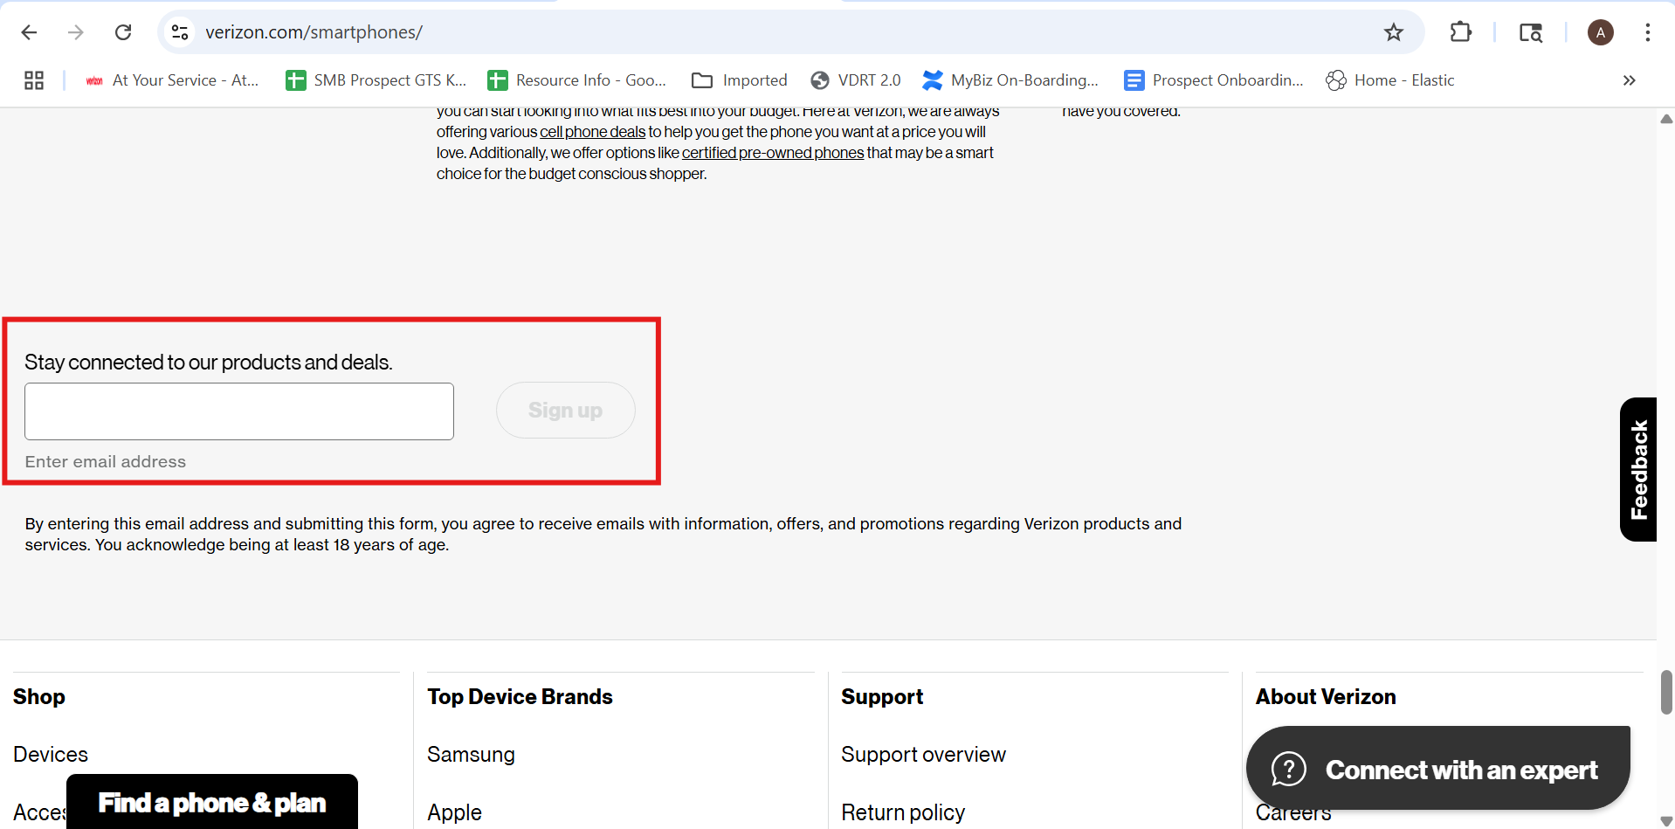 | 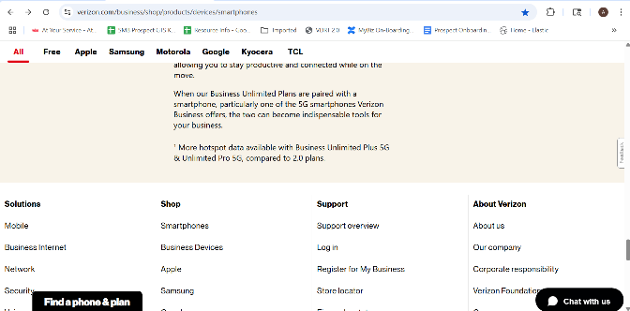

3.The Zipcode providing dialog box is asked IN VBG but not in VCG
VCG | VBG
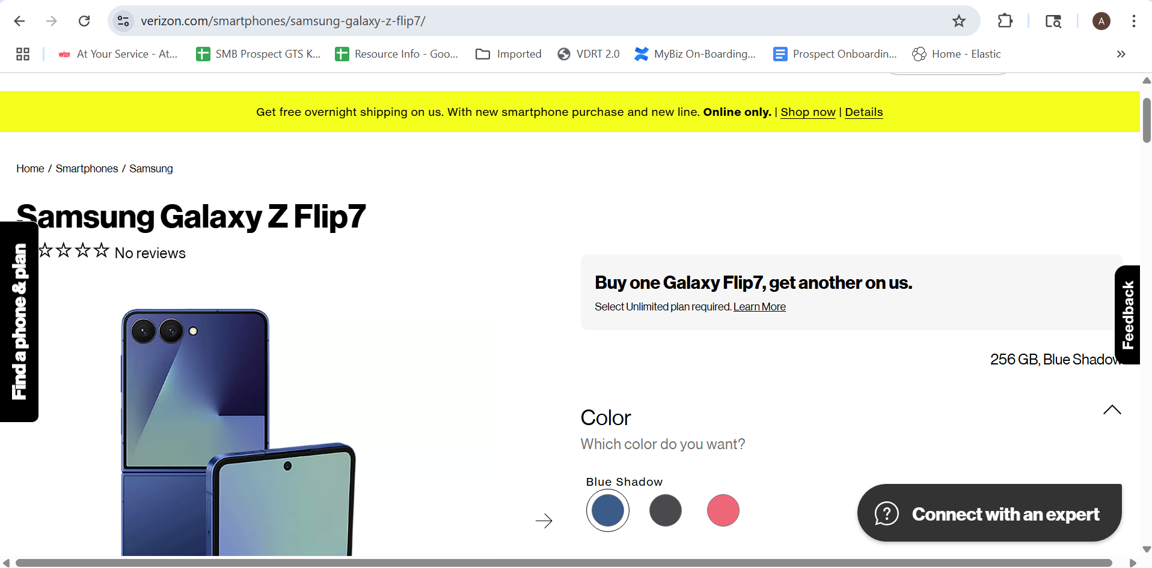 | 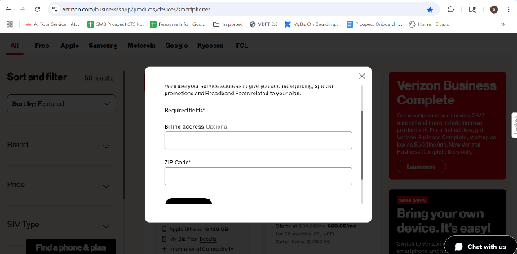
4. The Ways to save option in VBG is not their in VCG.
VCG | VBG
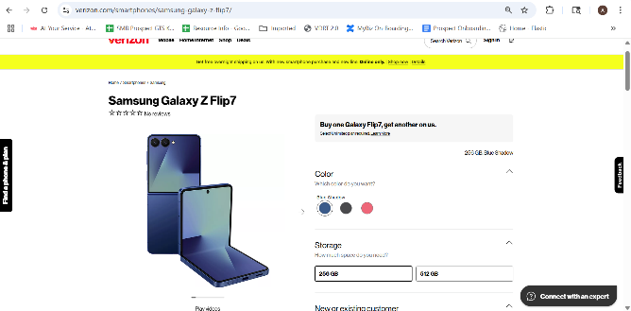 | 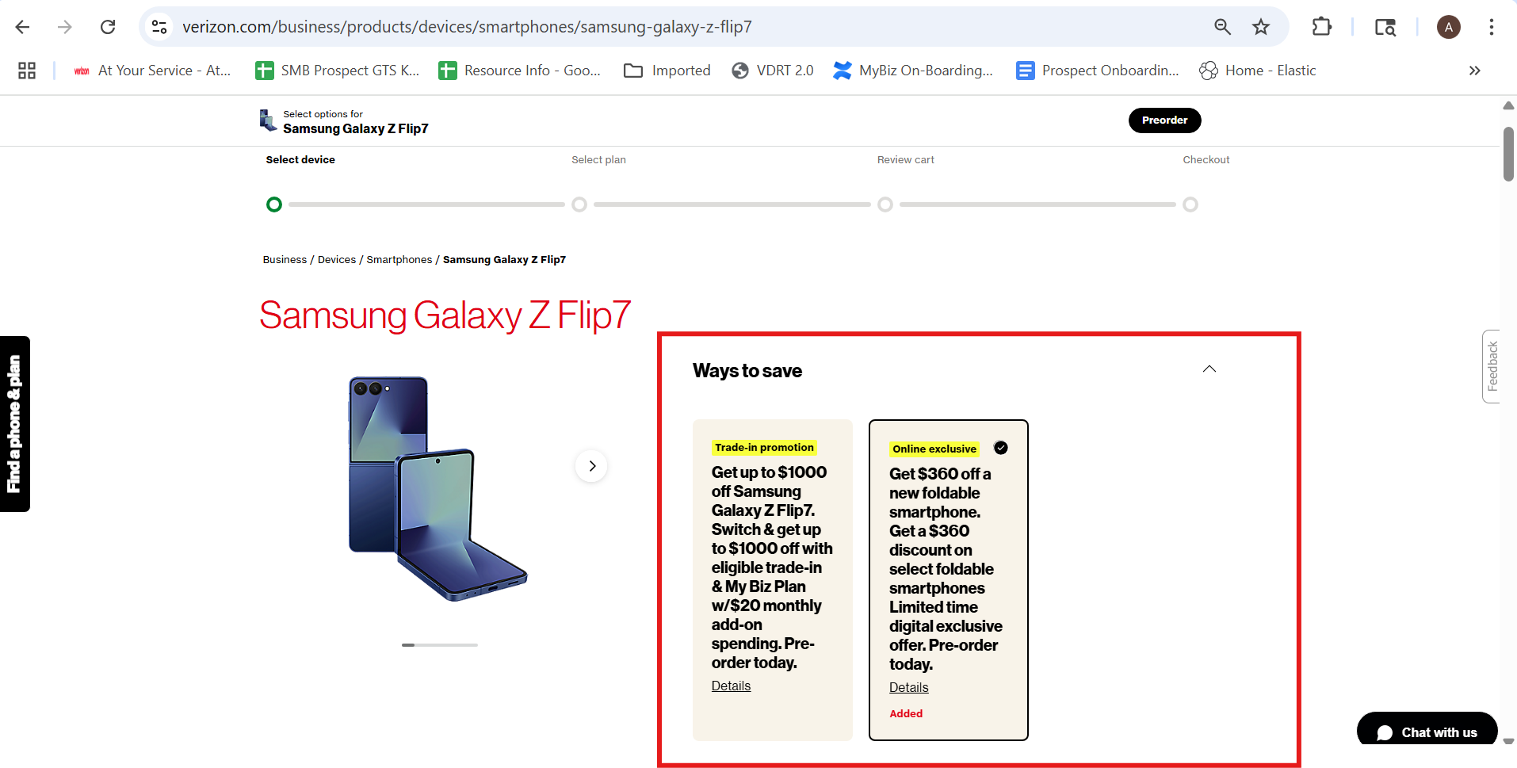

5. The payment Option is not their in VCG
VCG | VBG
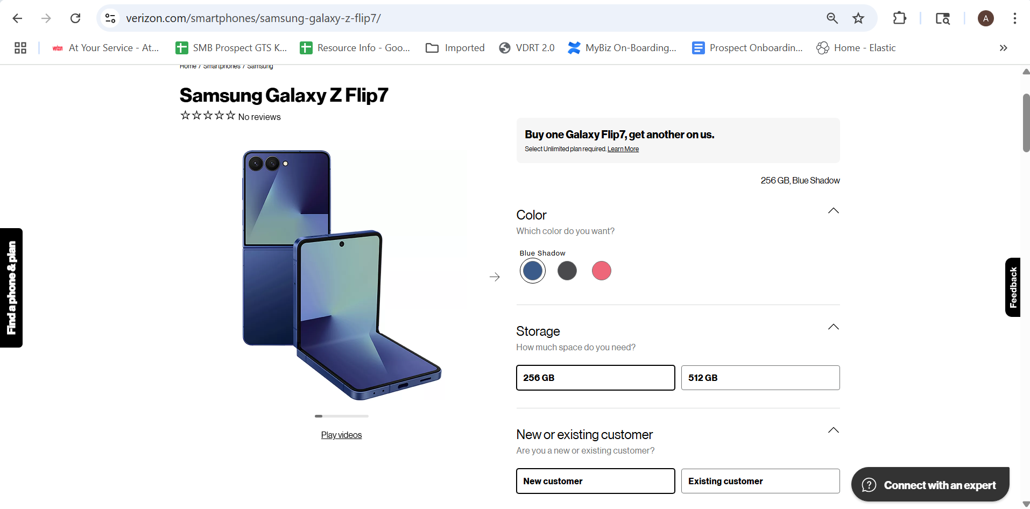 | 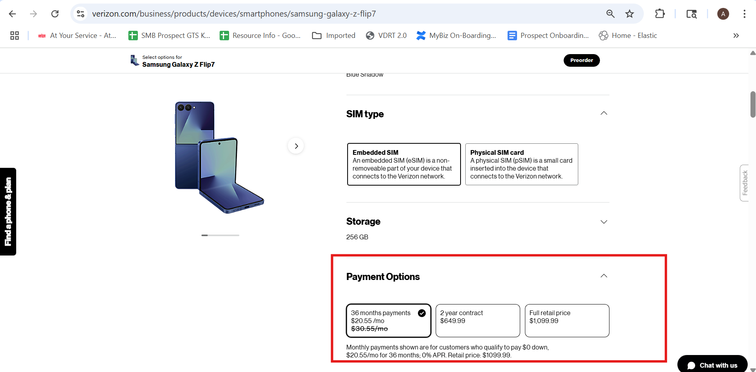

6. The protect your device option is not available in VCG but it is been displayed as sperate page after plans page.
VCG | VBC
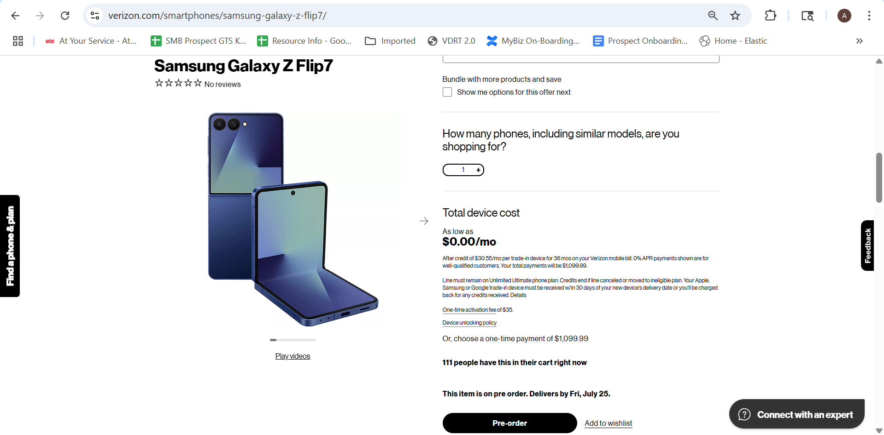 | 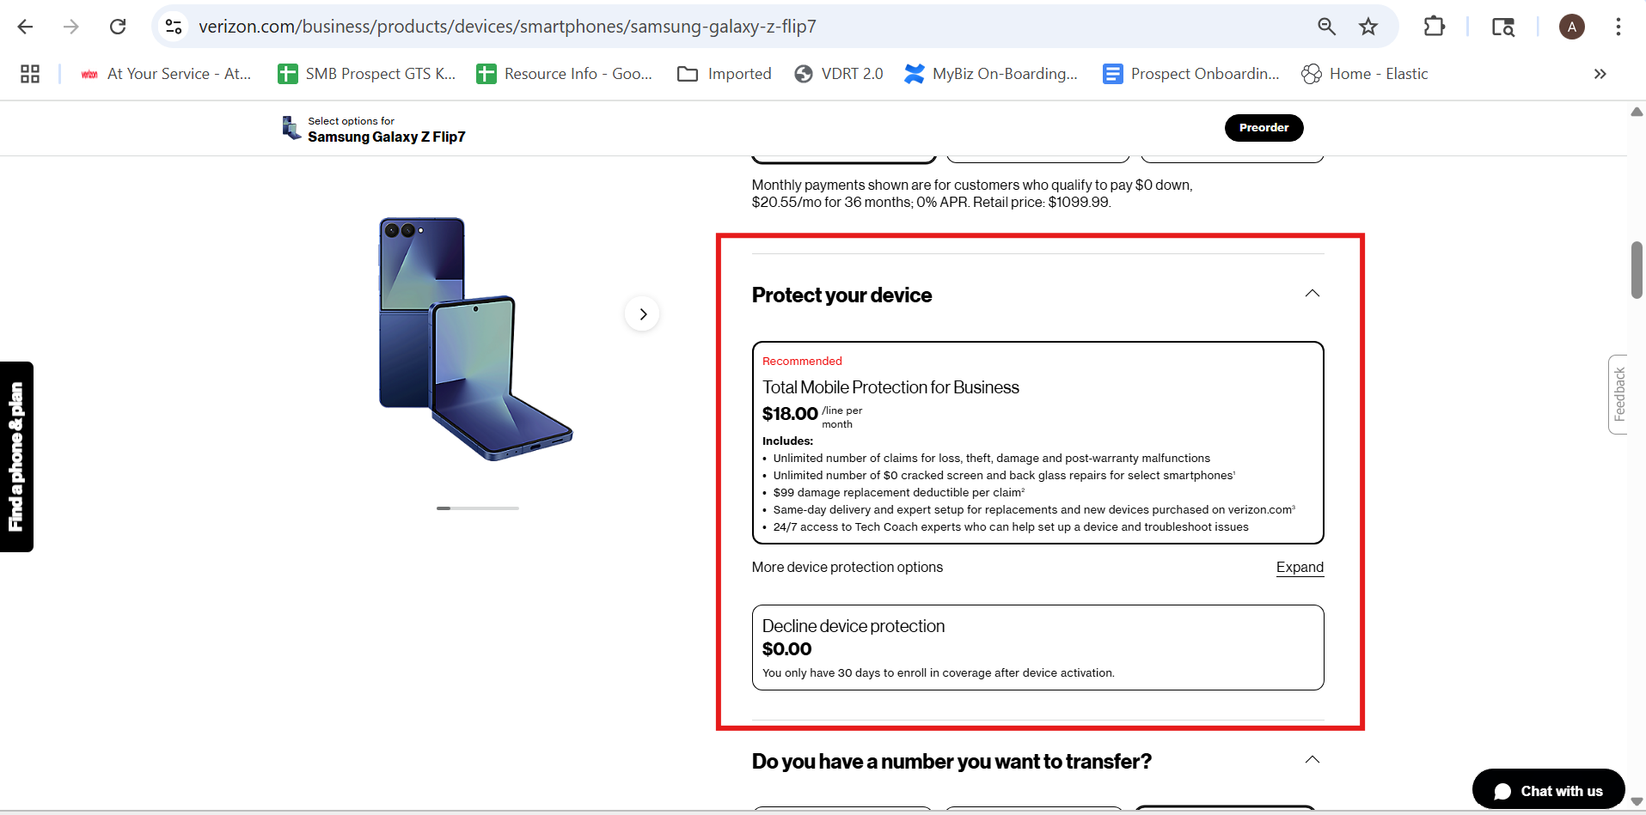

7. The extended carrier lock option is not their in VCG
VCG | VBG
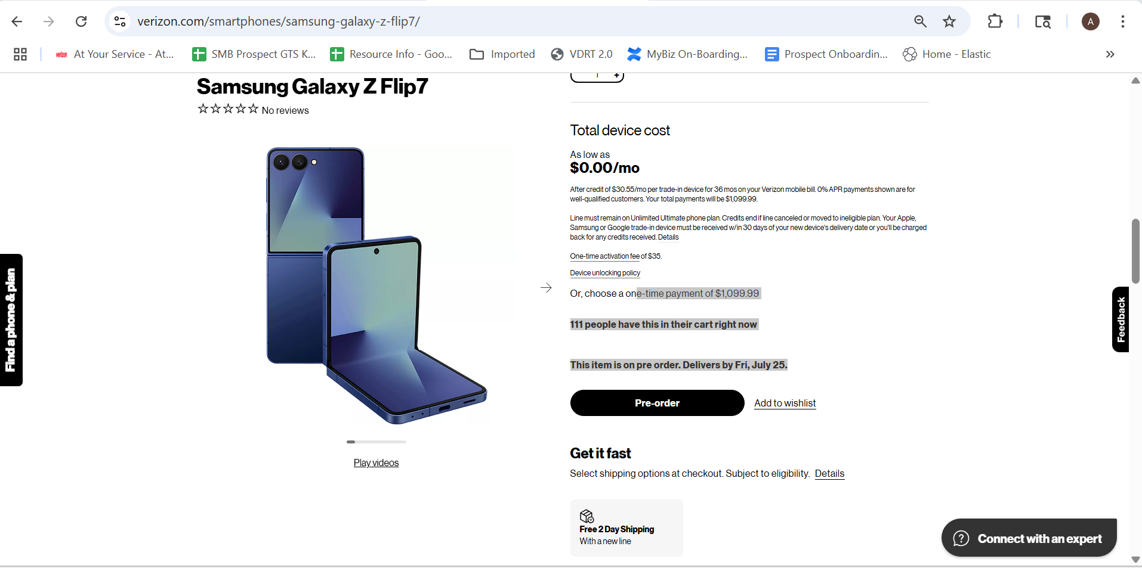 | 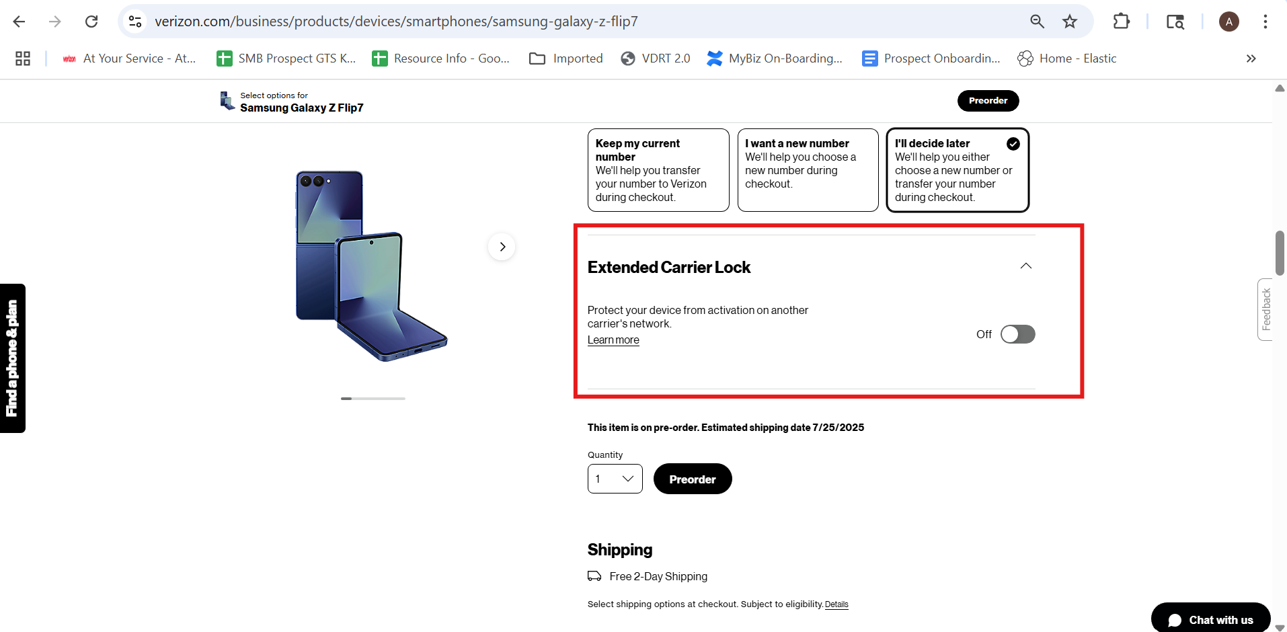

8. The Selected for you option is not their in VBG
VCG | VBG
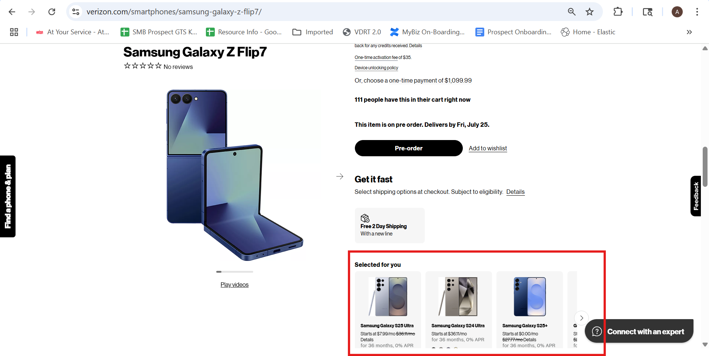 | 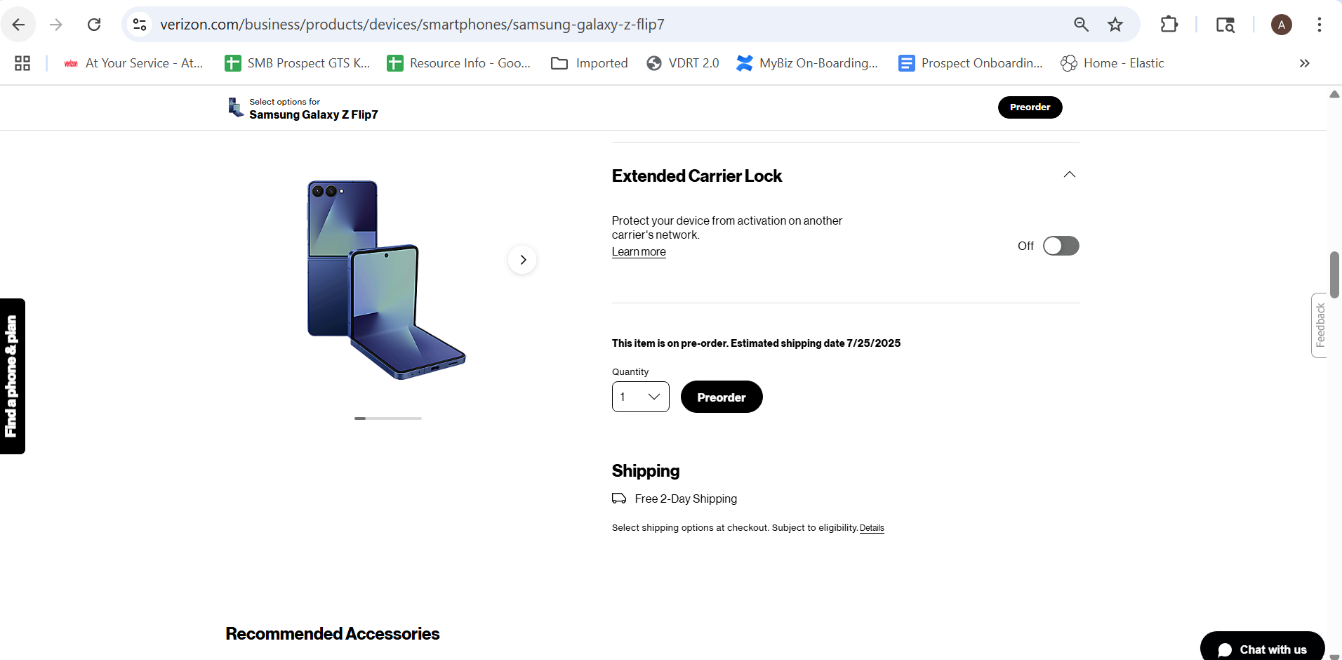

9. The Recommended Accessories is not there in VCG but it is been displayed as separate page after device protection page.
VCG | VBG
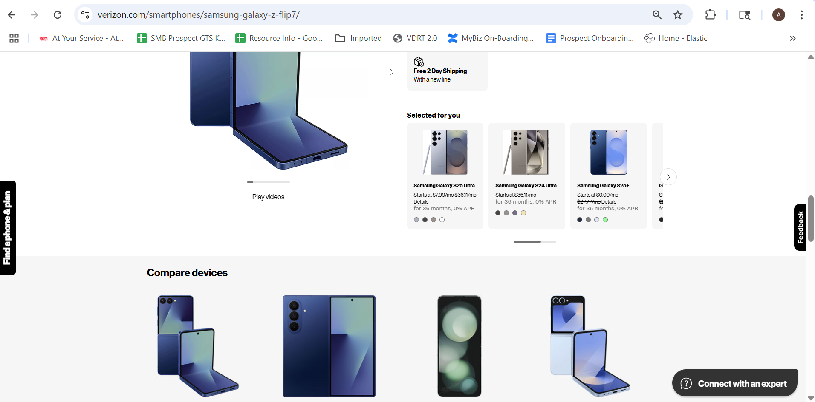 | 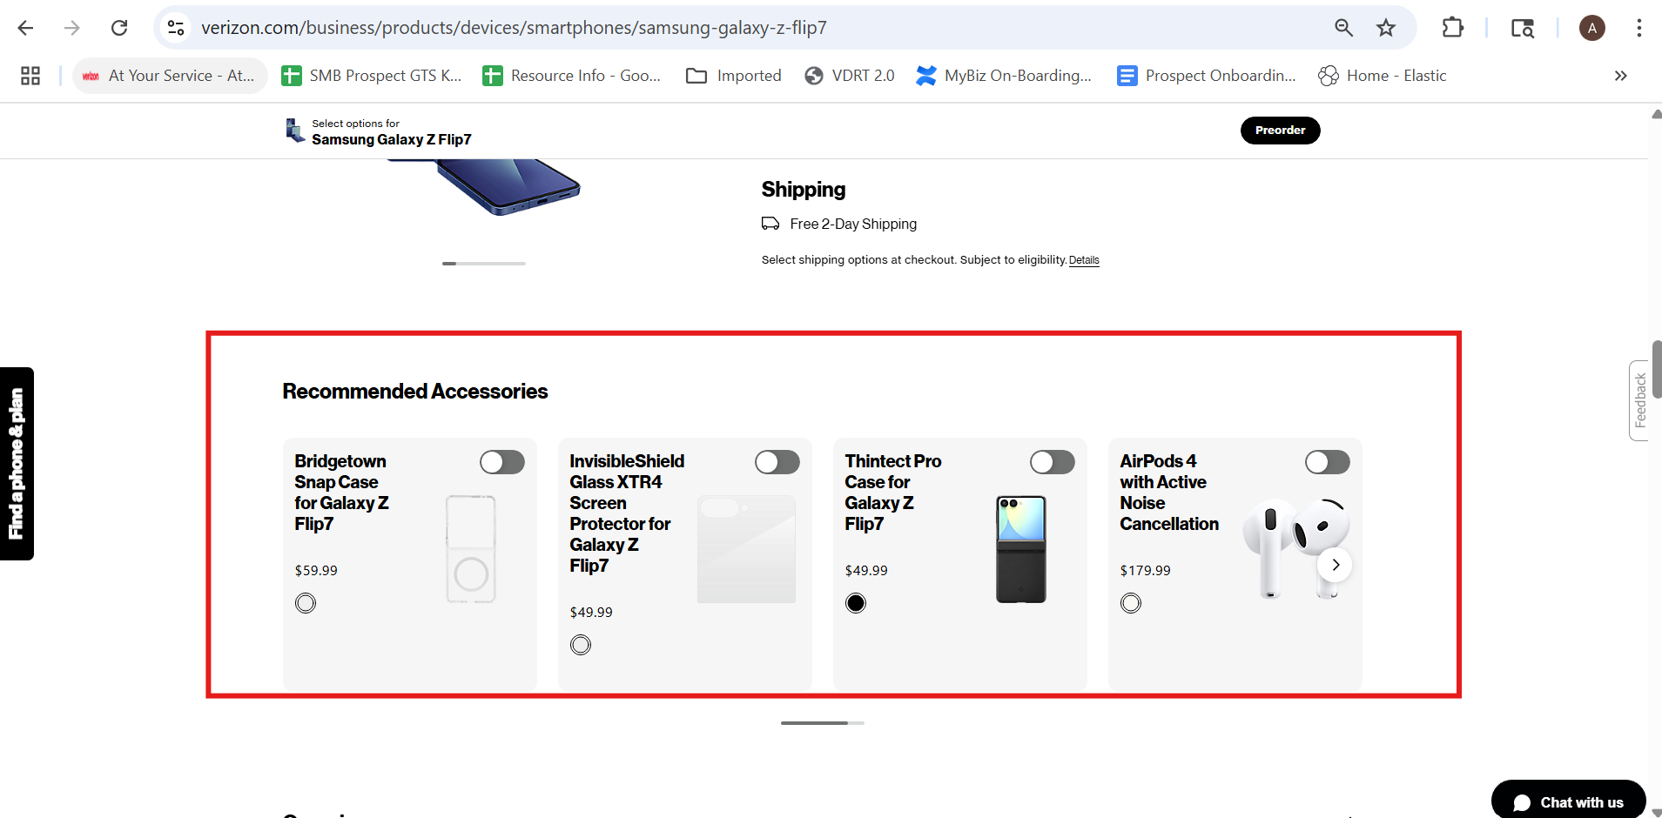

10.Displaying Offers According to type customer is not their in VBG.
VCG | VBG
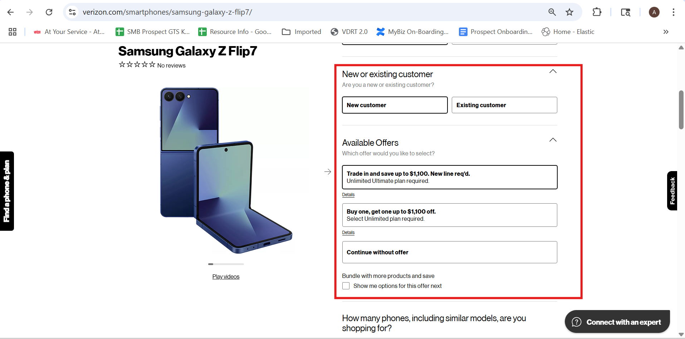 | 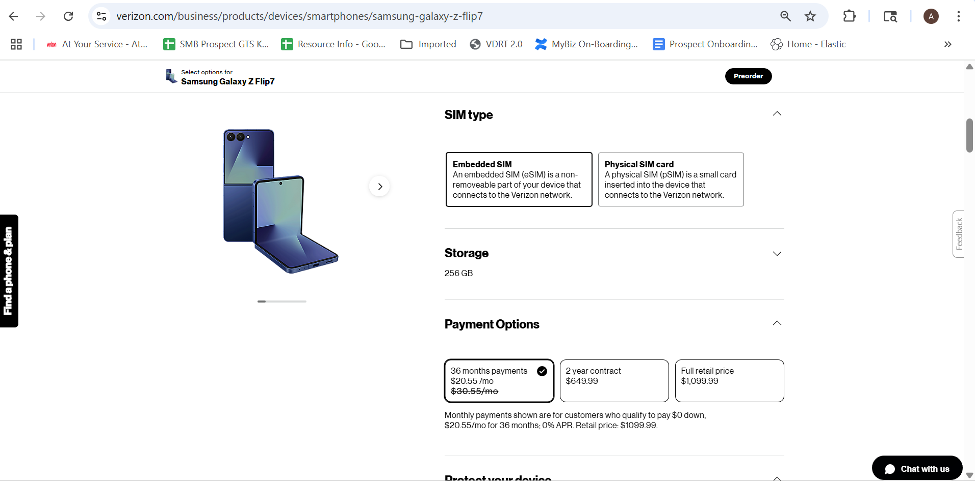

11. The sales page itself completely missing in VBG goes directly to plans page.
VCG | VBG
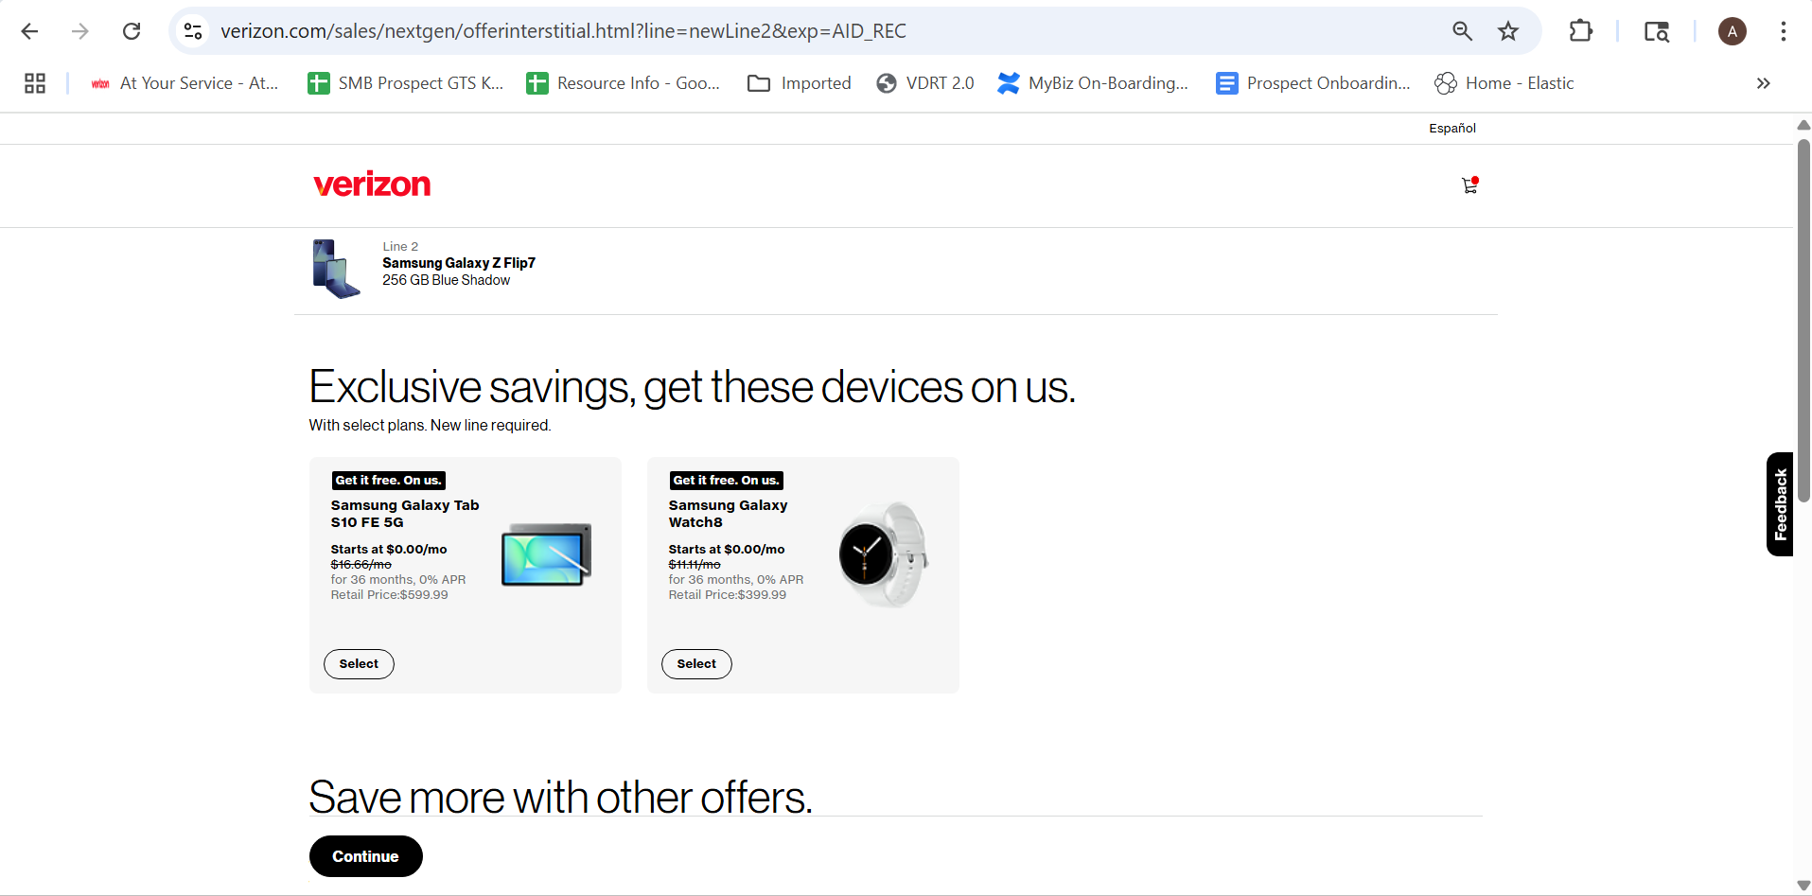 | 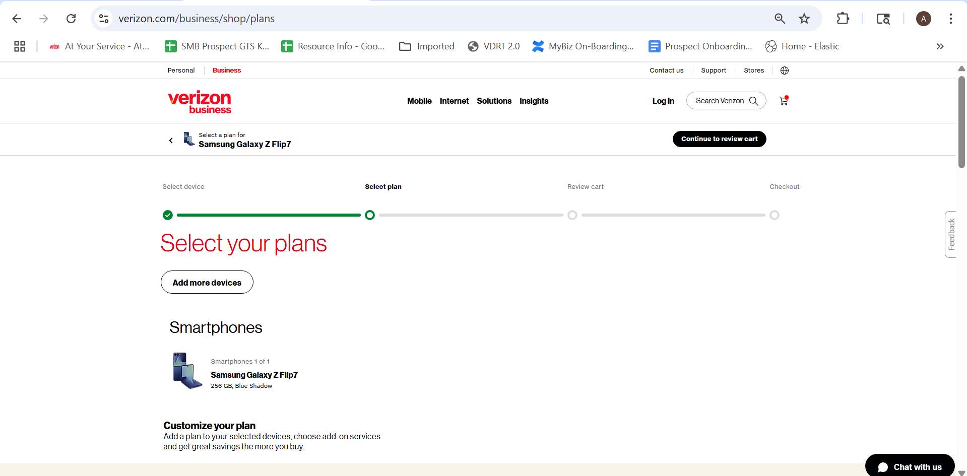

12. The plans in VCG and VBG differs as VBG has only one plan(My Biz) .
VCG | VBG
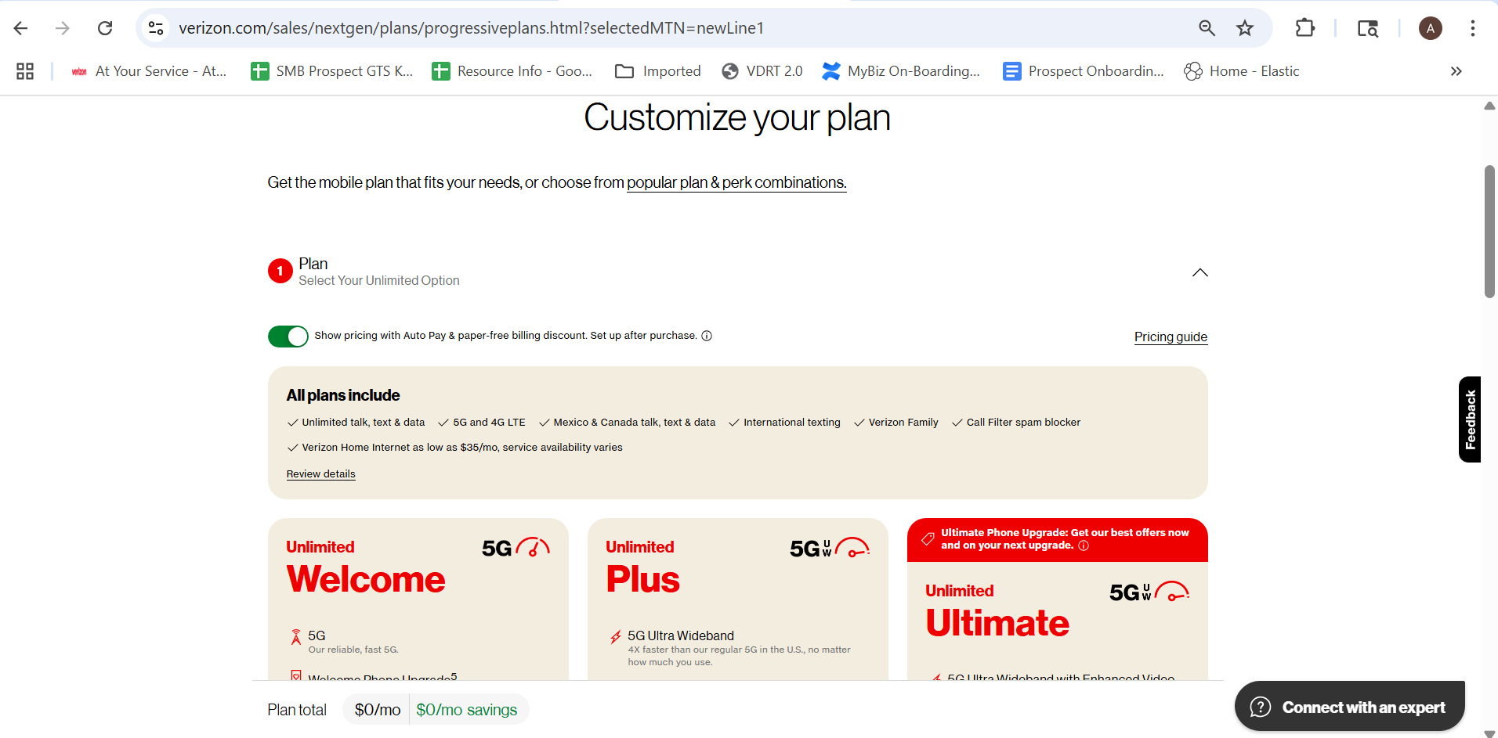 | 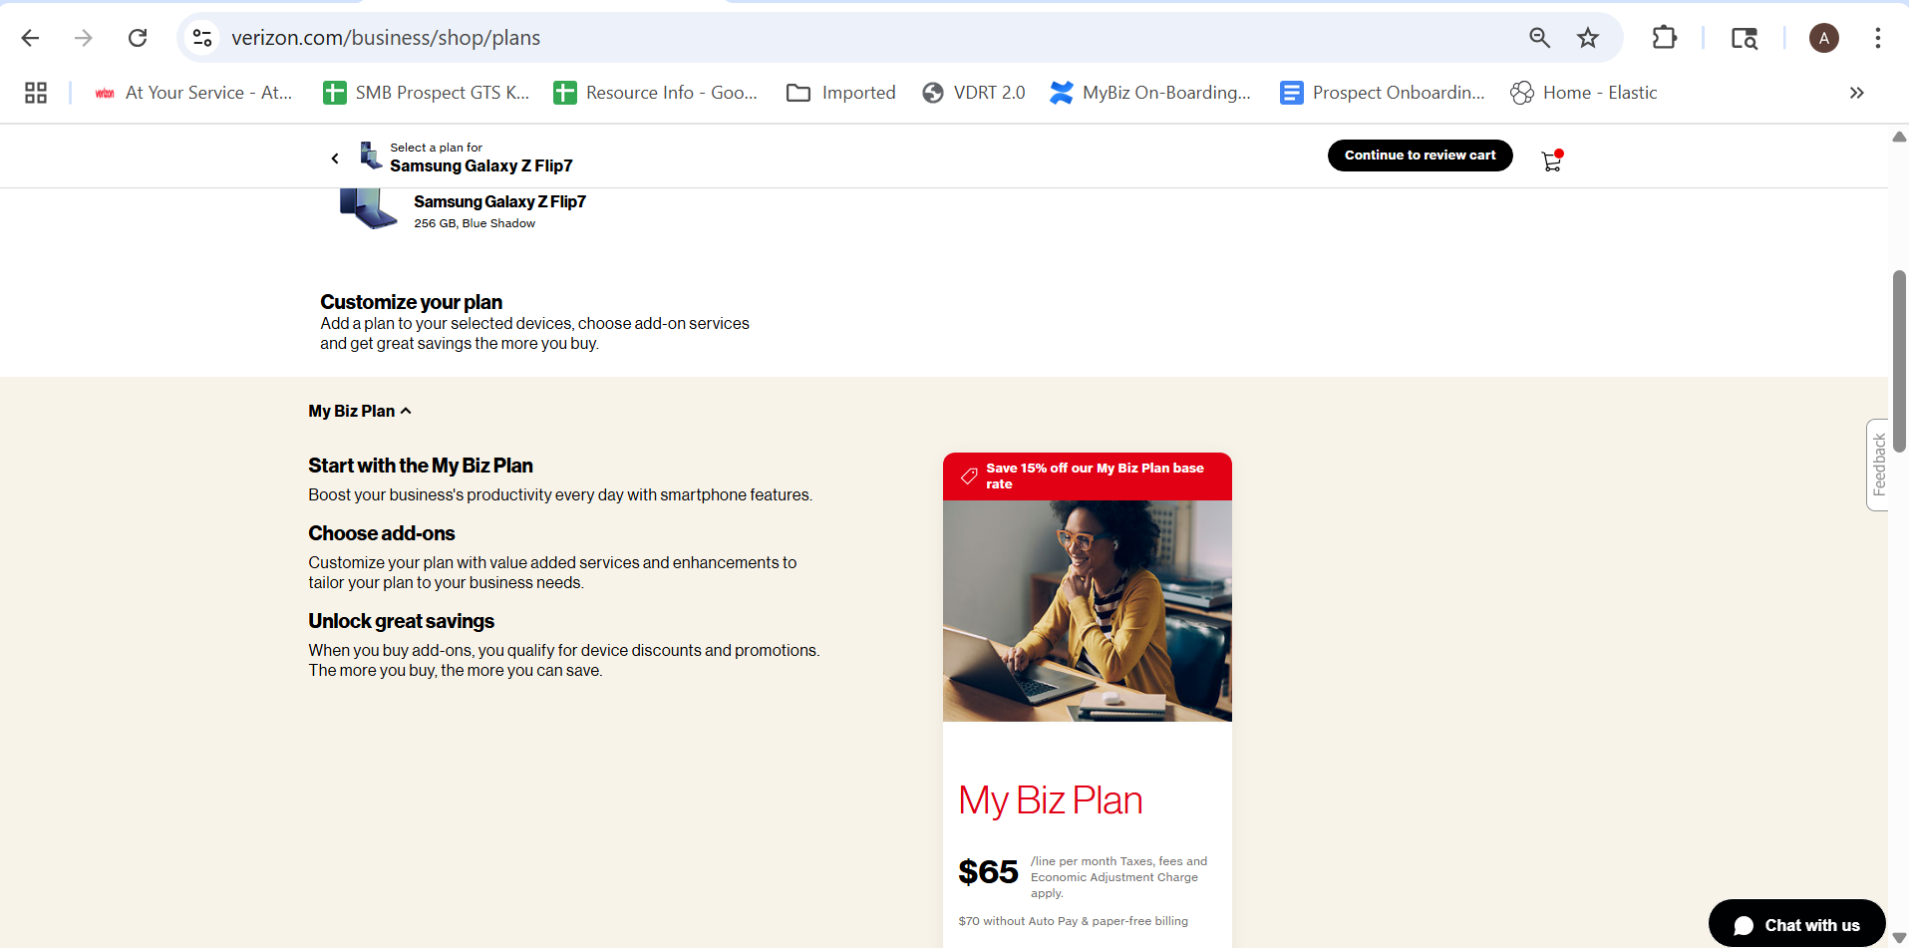

13. As perks option available in VCG we have Add-ons for plans in VBG.
VCG | VBG
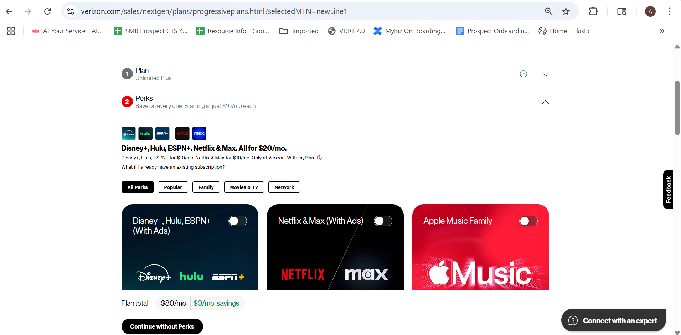 | 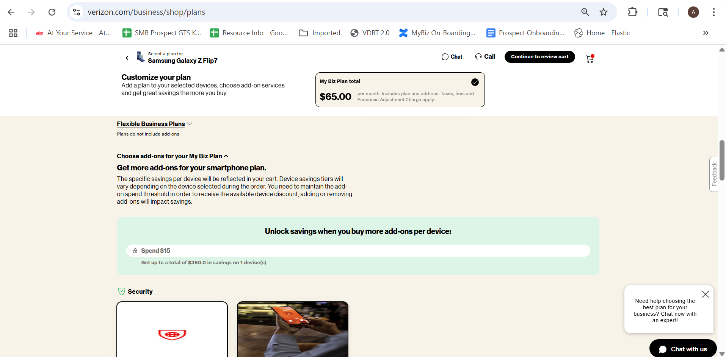

14. The Broadband facts are available in VCG but not in VBG
VCG | VBG
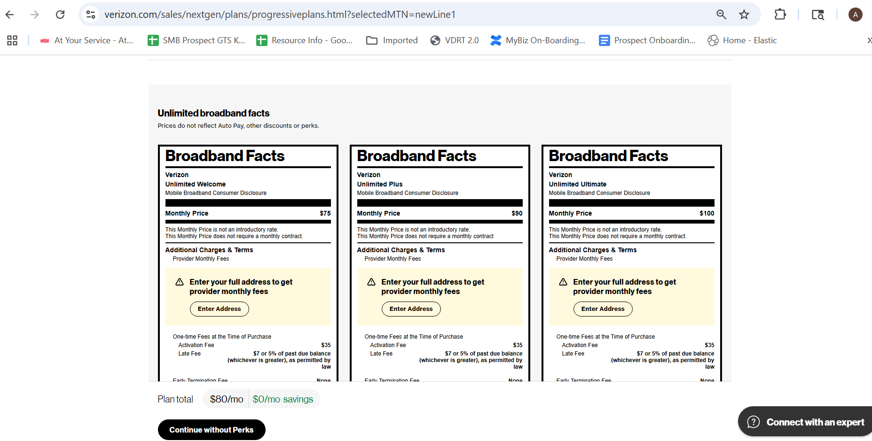 | 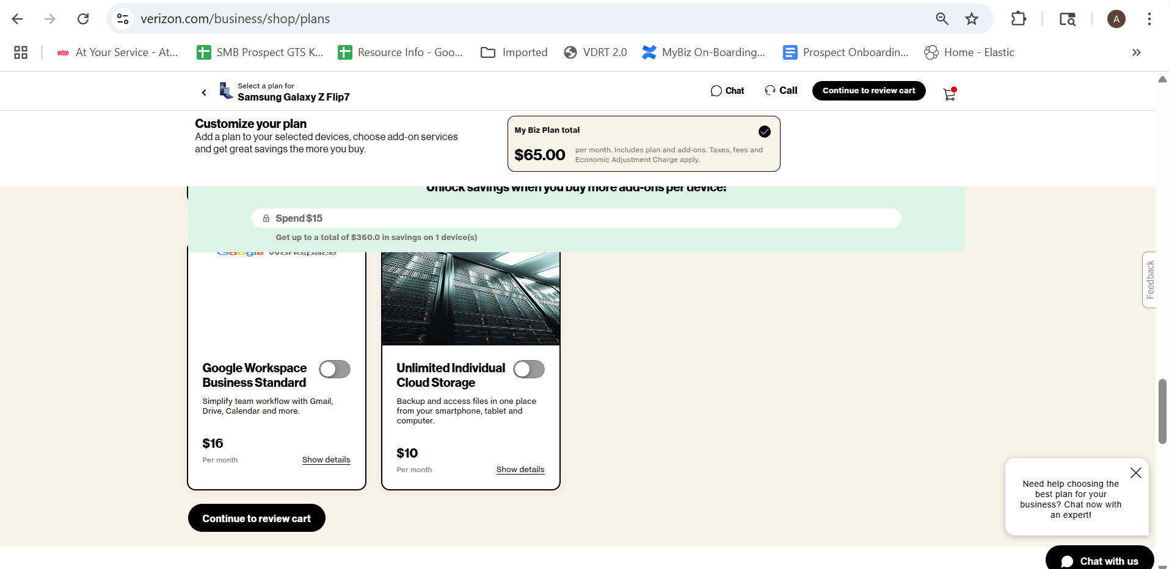

15. The Trade-in and add more device in review cart page of VBG is not present VCG
VCG | VBG
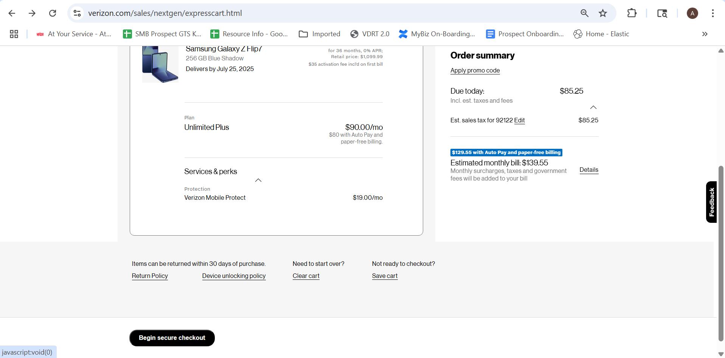 | 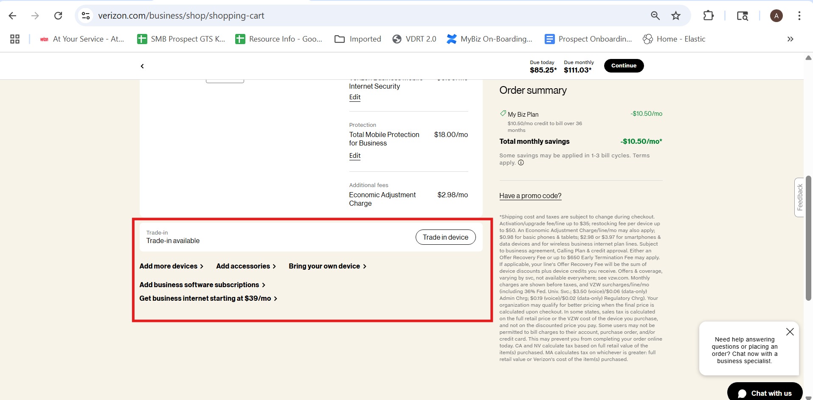

16. The promo code option in review cart page is not their in VCG
VCG | VBG
 | 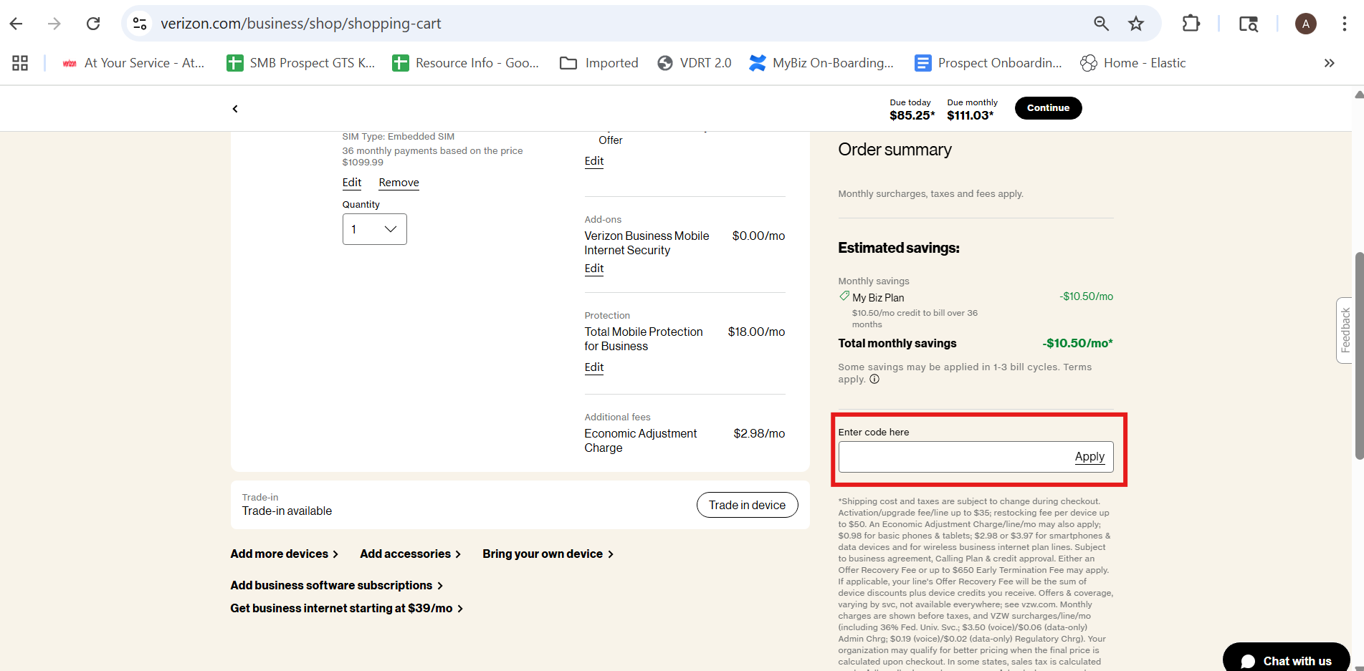

17.The Device Unlocking policy in Review cart page of VCG is not available in VBG on return policy is there.
VCG | VBG
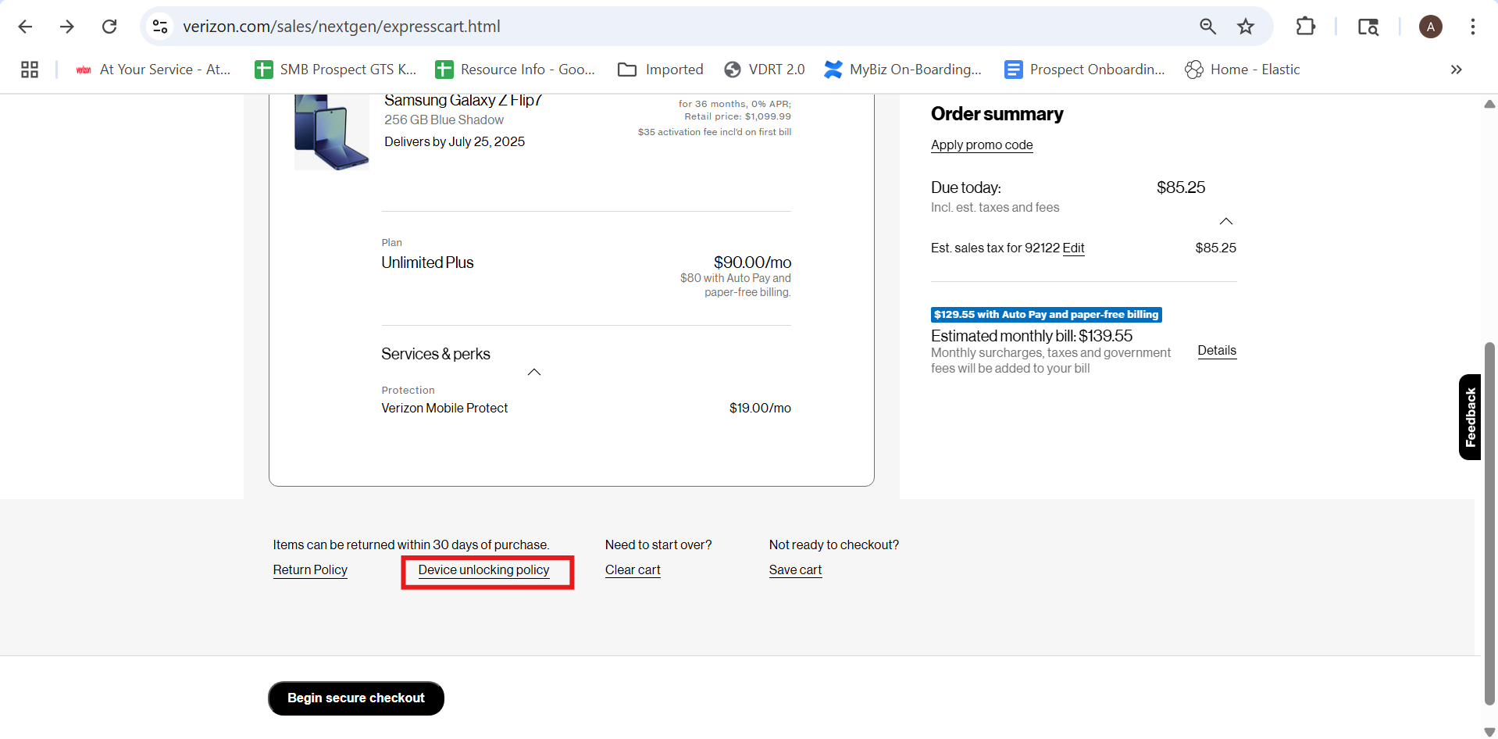 | 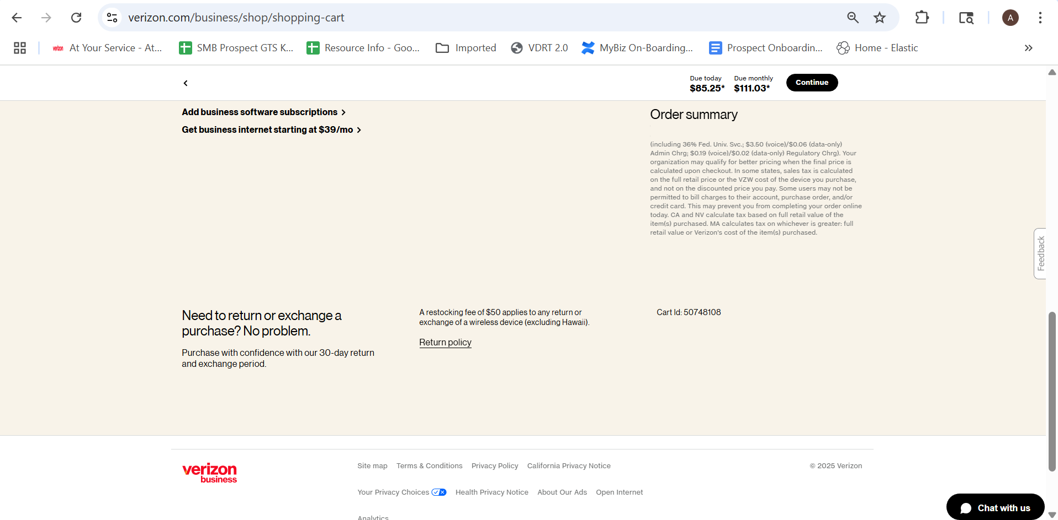

18. The save extra off banner is not popping up in VCG
VCG | VBG
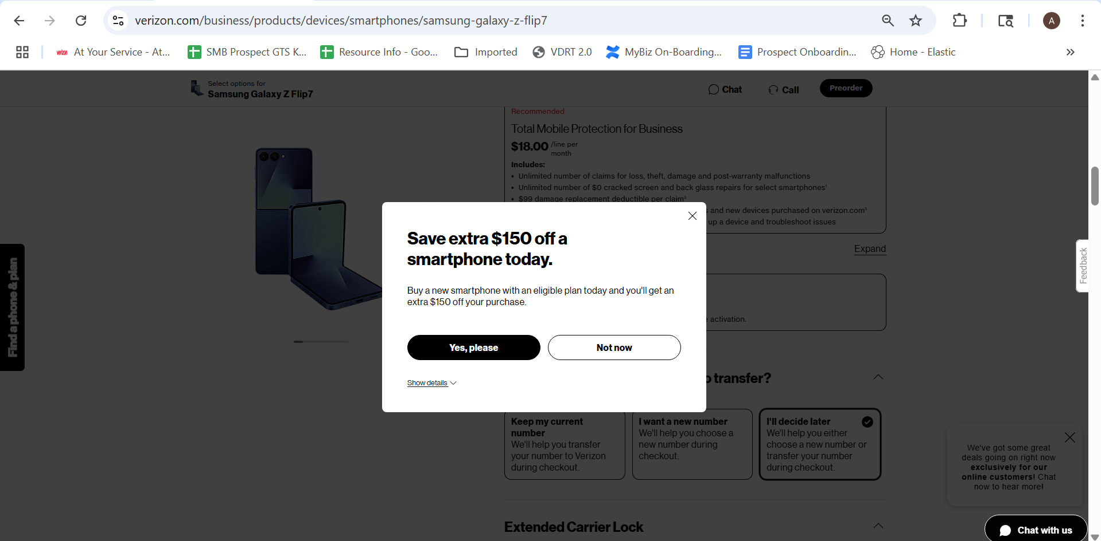 | 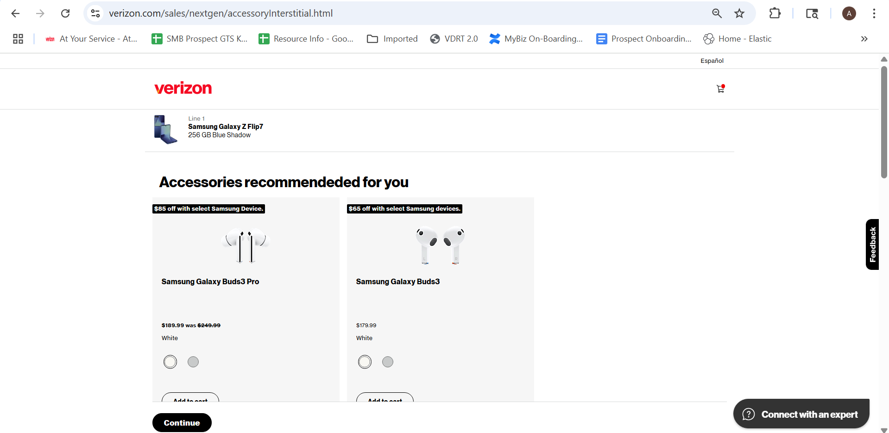

19. The Lower funnel section of VBG has different section in single page but in VCG we have Different page for each section
VCG | VBG
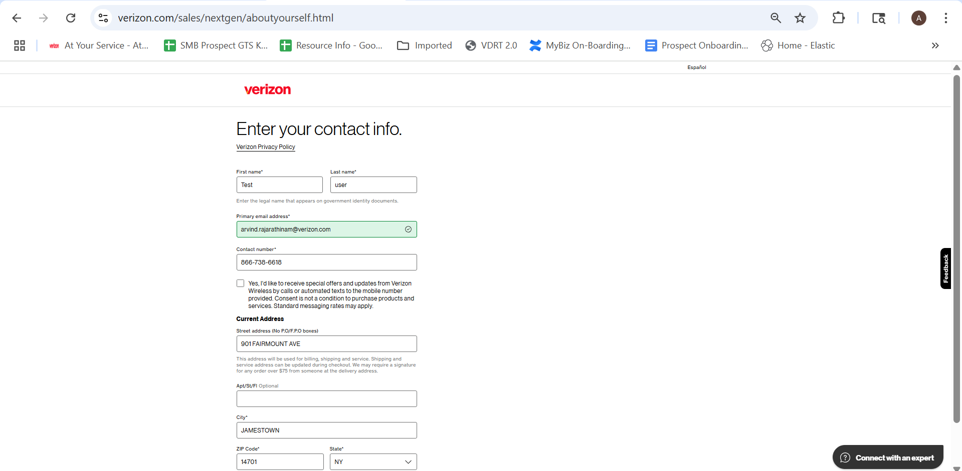 | 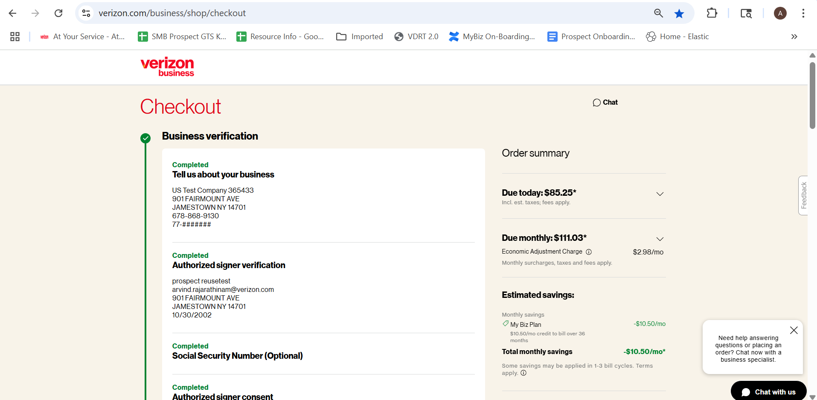
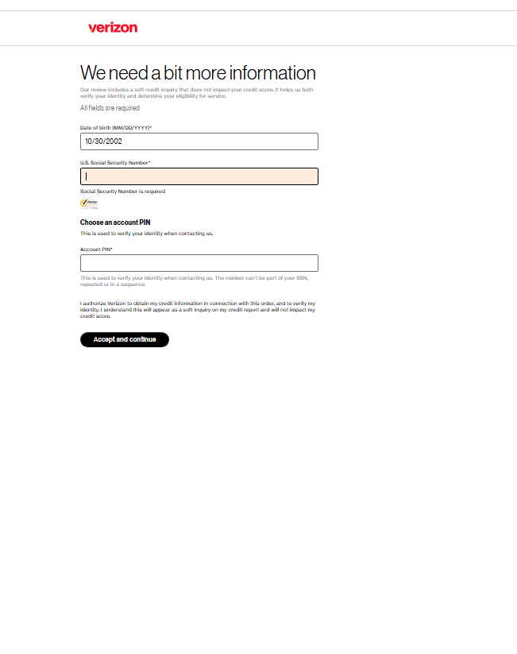 | 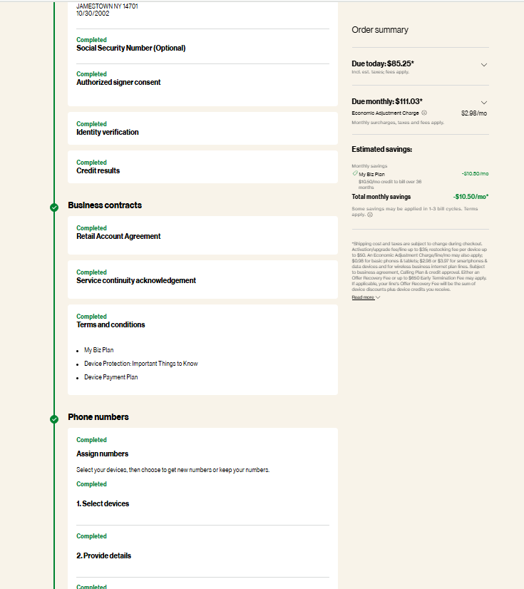

20. The Device plan protection is their in PDP page in VBG but in VBC it has it as separate for accessories, device protection plan, get number and etc
VCG | VBG
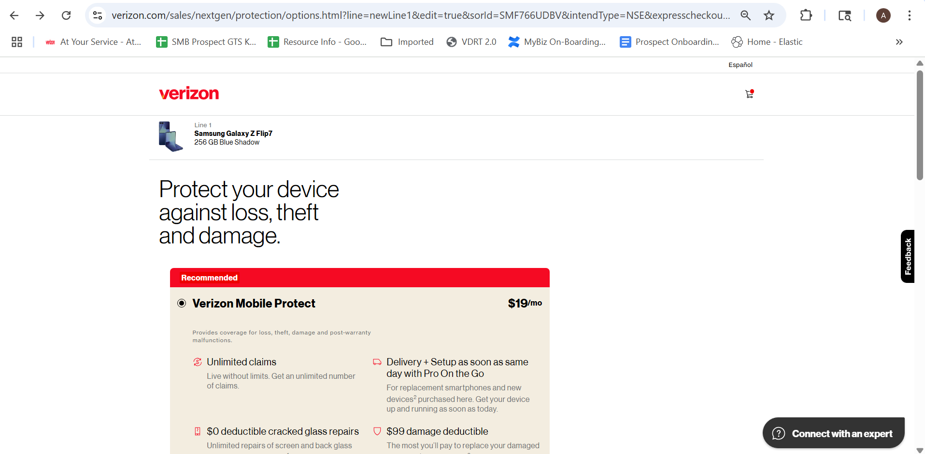 | 

